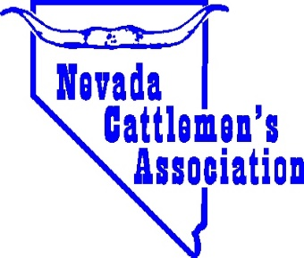
NEVADA CATTLEMEN’S ASSOCIATION
2023 Teacher of the Year Award
*Agriculture teachers are not eligible

Teacher’s Name: Grade taught:

School Name:

School Address: ____________________________________________ City, Zip

School Phone Number: ________________________ Teacher’s Phone Number:

RE: The Nominee: Years of teaching? ___________________ Years teaching in Nevada?

NCA Member: Y/N How many students received agricultural instruction from the teacher this year?

Has the teacher ever participated in “Ag In the Classroom” courses?

On a separate attachment to this form, please tell us how the Nominee integrates agriculture into their curriculum and classroom. Also include why you chose to nominate this person as the “Teacher of the Year” and additional information such as your favorite story about the teacher, the teacher’s background, or the main resources that were used for the basis and classes of agricultural instruction.

Nominated By: _________________________________________ Title, if any: __________________________

Your Address: __________________________________________ City, Zip: ____________________________

Your Phone Number: _____________________________________ Email:_________________________

For any questions, please contact the NCA office at 775-738-9214. A completed nomination form is due June 16, 2023. Nominations may be submitted by email to nca@nevadabeef.org or sent by mail to “Teacher of the Year Nomination”, C/O Nevada Cattlemen’s Association, P.O. Box 310, Elko, NV 89803.

