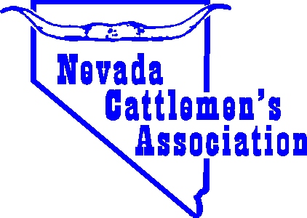
NEVADA CATTLEMEN’S ASSOCIATION
2022 Teacher of the Year Award
Application Form – Please Print Contact Information
DEADLINE: November 1, 2022
FAX to: 775 738 5208 – EMAIL to: nca@nevadabeef.org – MAIL to:
“Teacher of the Year”, C/O NV Cattlemen’s Assn., P O Box 310, Elko, NV 89803

Teacher’s Name: Grade taught:

School Name:

School Address: ____________________________________________ City, Zip

School Phone Number: ________________________ Teacher’s Phone Number:

RE: The Nominee: Years of teaching? ___________________ Years teaching in Nevada?

NCA Member: Y/N How many students received agricultural instruction from the teacher this year?

Has the teacher ever participated in “Ag In the Classroom” courses?

Please provide a short essay (up to of 750 words) detailing how the Nominee integrates agriculture into their curriculum and classroom, why you chose to nominate this person as the “Teacher of the Year”, and additional information such as your favorite story about the teacher, the teacher’s background, or the main resources that were used for the basis and classes of agricultural instruction.

Nominated By: _________________________________________ Title, if any: __________________________

Your Address: __________________________________________________ City, Zip__________________________

Your Phone Number: ____________________________ Cell Phone Number: _______________________________

Thank you in advance for your time and assistance in helping Nevada Cattlemen’s Association recognize the efforts of your nominee to teach about ranching and agriculture in Nevada.

